***How Kafka works?***

Kafka is a distributed system consisting of servers and clients that communicate via a high-performance TCP network protocol. It can be deployed on bare-metal hardware, virtual machines, and containers in on-premise as well as cloud environments.

**Topics**

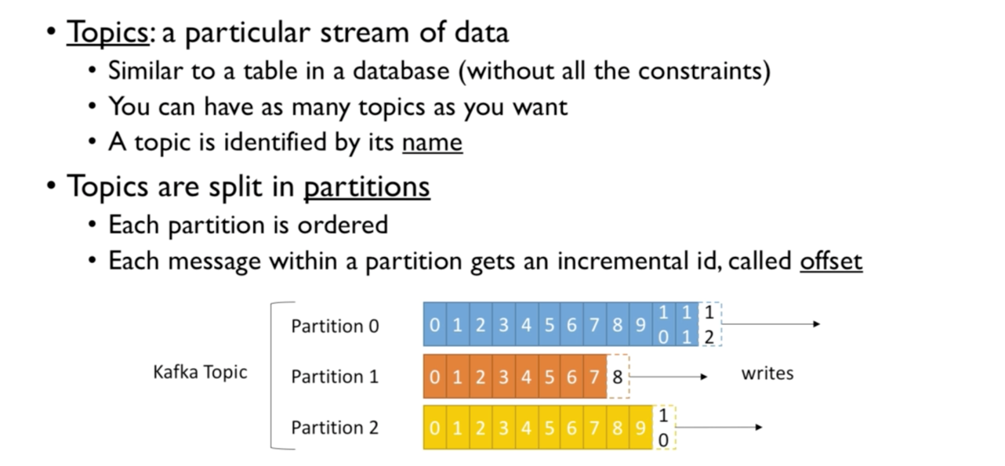

**Brokers**

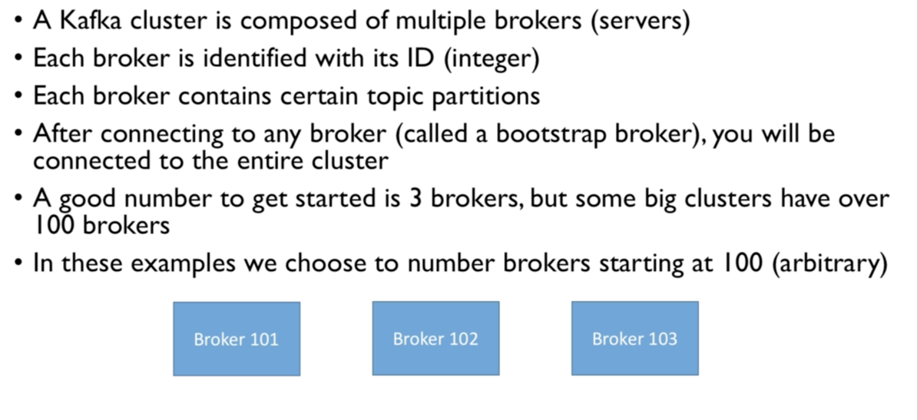

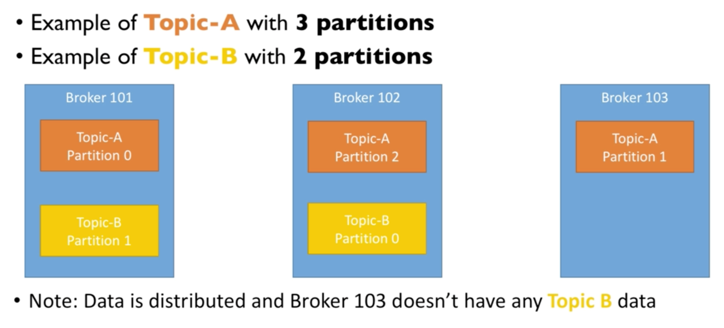

**Producers**

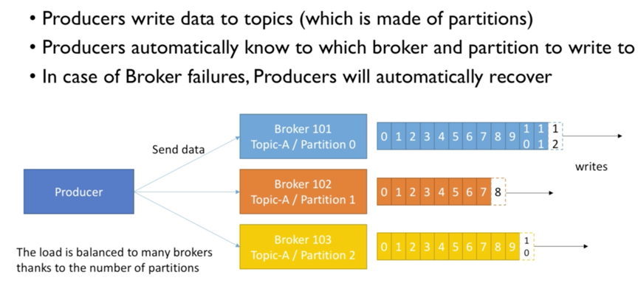

**Consumers**

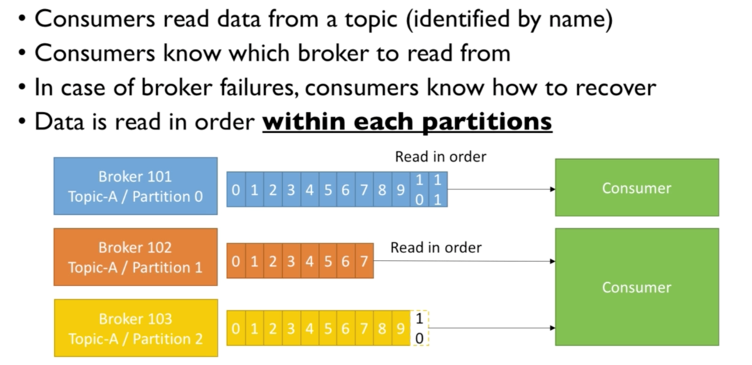

**Role of Zookeeper in Kafka**

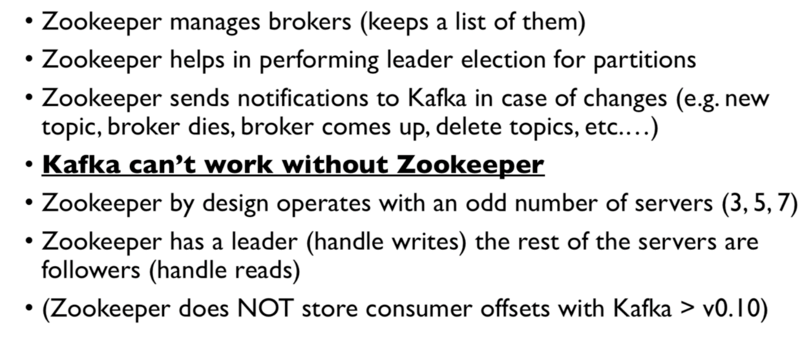

**Recap**

